B.SARAVANAN

230701293

EXPERIMENT 6

**Simulate the lifecycle stages for UI design using the RAD model and develop a small interactive interface using**

**Axure RP**

**AIM:**

The aim is to demonstrate the lifecycle stages of UI design via the RAD model and develop a small interactive interface employing Axure RP.

**PROCEDURE:**

Tool Link: https://www.axure.com/

Simulating the Lifecycle Stages for UI Design Using the RAD Model

RAD Model (Rapid Application Development): The RAD model emphasizes quick development and iteration. It consists of the following phases:

1. Requirements Planning:

○ Gather initial requirements and identify key features of the UI.

○ Engage stakeholders to understand their needs and expectations.

2. User Design:

○ Create initial prototypes and wireframes.

○ Conduct user feedback sessions to refine the designs.

○ Use tools like Axure RP to develop interactive prototypes.

3. Construction:

○ Develop the actual UI based on the refined designs.

○ Perform iterative testing and feedback cycles.

4. Cutover:

○ Deploy the final UI.

○ Conduct user training and support.

Axure RP Interactive Interface Development

Phase 1: Requirements Planning

1. Identify Key Features:

○ Navigation (Home, Product Categories, Product Details, Cart,

Checkout,

Order Confirmation, Order History)

○ User actions (Browsing, Searching, Adding to Cart, Checkout, Tracking Orders)

2. Create a Requirements Document:

○ List all features and functionalities.

○ Document user stories and use cases.

Phase 2: User Design

1. Install and Launch Axure RP:

○ Download and install Axure RP from Axure&'s official website.

○ Launch the application.

2. Create a New Project:

○ Go to File -&gt; New to create a new project.

○ Name the project (e.g., "Shopping App Interface").

3. Create Wireframes:

○ Use the widget library to drag and drop elements onto the canvas.

○ Design wireframes for each screen:

■ Home Page

■ Product Categories

■ Product Listings

■ Product Details

■ Cart

■ Checkout

■ Order Confirmation

■ Order History

4. Add Interactions:

○ Select an element (e.g., button) and go to the Properties panel.

○ Click on Interactions and choose an interaction (e.g., OnClick).

○ Define the action (e.g., navigate to another screen).

5. Create Masters:

○ Create reusable components (e.g., headers, footers) using Masters.

○ Drag and drop masters onto the wireframes.

6. Add Annotations:

○ Add notes to describe each element's purpose and functionality.

○ Use the Notes panel to add detailed annotations.

Phase 3: Construction

1. Develop Interactive Prototypes:

○ Convert wireframes into interactive prototypes by adding interactions and transitions.

○ Use dynamic panels to create interactive elements (e.g., carousels, pop - ups).

2. Test and Iterate:

○ Preview the prototype using the Preview button.

○ Gather feedback from users and stakeholders.

○ Make necessary adjustments based on feedback.

Phase 4: Cutover

1. Finalize and Export:

○ Finalize the design and interactions.

○ Export the prototype as an HTML file or share it via Axure Cloud.

2. User Training and Support:

○ Conduct training sessions to familiarize users with the new interface.

○ Provide documentation and support for any issues.

**OUTPUT:**

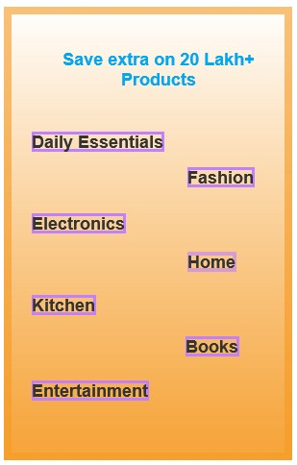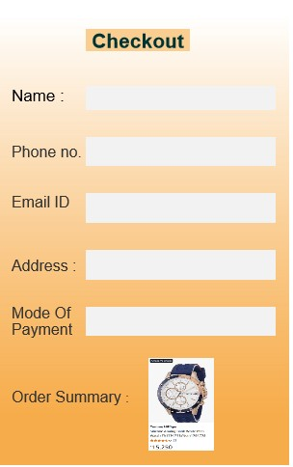

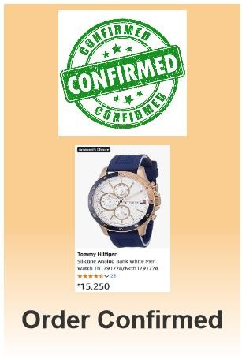

**RESULT:**

Hence, demonstration of the lifecycle stages of UI design via the RAD model and develop a small interactive interface employing Axure RP.